A Mathematical Model for Determining the Five Daily Islamic Prayer Times

draft research paper

Raeid Usmanali
October 26, 2026

Introduction and Scope
In this document, I plan to go over the evidence, interpretation, observation, astronomical condition, and equation for calculating the entrance time for each of the five daily prayers within the Islamic Faith.
…

Mathematical Understanding

Geographic Coordinate Systems and Conventions
- Establish where the observer is located on Earth
  - How we represent that position mathematically
- How to establish a sense of direction
  - Reference direction specifically for solar angles
- Before we can determine the Sun’s position relative to an observer, we need to define the observer’s position in a consistent (and mathematically sound) coordinate system

Modelling the Earth
- Inputs are latitude and longitude
- These coordinates only make sense relative to model of the Earth’s shape
- If the earth as a perfect sphere, every point on the surface would lie and equal distance R from the Earth’s center
- The Earth is not perfectly spherical
  - Closest approximation is an “oblate spheroid”
    - Oblate Spheroid is a sphere flattened slightly at the poles and wider around the equator. This is due to the effect of gravity on the Earth
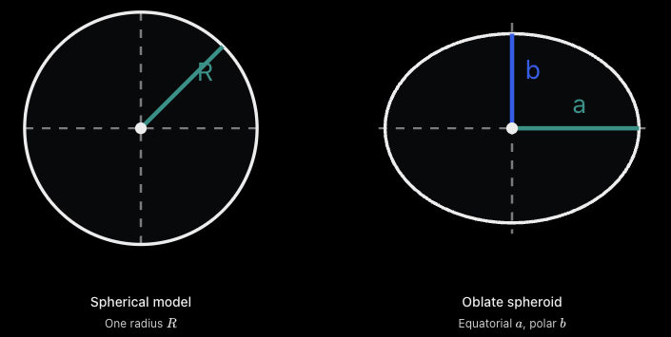
- For the sake of our model, we define
  - a: equatorial semi-major axis
  - b: polar semi-minor axis
  - f: flattening factor
  - f = (a-b)/a
  - Note that this quantifies how far the Earth departs from the perfect spherical model. If a = b, then f = 0
- For our model, we will adopt the World Geodetic System 1984 (WGS 84) which defines:
  - Equatorial semi-major axis (a) - 6,378,137 m
  - Inverse flattening (1/f) - 298.257223563
  - Polar semi-minor axis (b) - ≈ 6,356,752.314 m
  - Figures provided by the WGS 84 standard (citation here
- Note that compared to the SPA, Reda and Andreas account for flattening when calculating the Sun’s topocentric position. The SPA constants vary slightly from the exact WGS 84 parameters
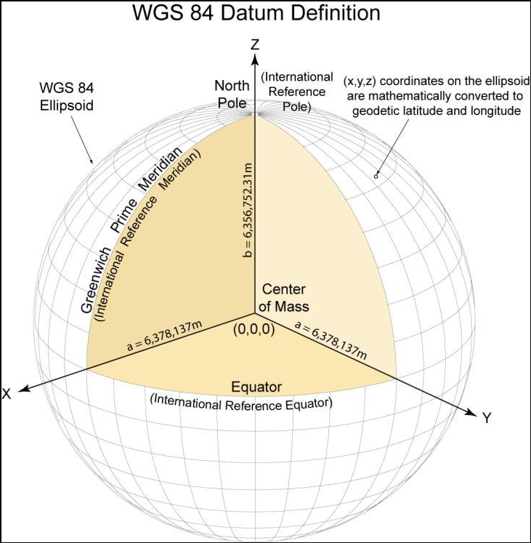

Latitude and Longitude
- The geographic position of an observer can be expressed in many ways. Our convention is as follows:
- P = (phi, lambda)
  - -90 <= phi <= 90
  - -180 <= lambda <= 180
  - In degrees
- Where:
  - phi = geographic latitude (North +ve, south -ve)
  - Lambda = geographic longitude (East +ve, west -ve)
- Lattitude (phi)
  - Specifies a location’s north-south position relative to the equator
  - Note that if the earth were spherical, this would simply be the angle between the equatorial plane and line connecting the observer to the Earth’s center
  - At the equator phi = 0, at the north pole phi = 90
  - This definition requires some adjustment due to our ellipsoidal Earth
  - [insert diagram for latitude]
- Longitude (lambda)
  - Speficies the east-west angular position of a location relative to a reference meridian
  - The standard reference meridian is the Greenwich prime meridian, assigned a longitude of 0
  - Each meridian is a plane passing through the Earth’s rotational axis
  - Longitude is not an angle measurd along Earth’s curved surface
    - It is an angular separation between meridian planes (cite reda & andreas here)
  - [insert longitude diagram]
- Why keep longitude if we already know the time?
  - Geographic longitude affects the observer’s relationship to the sun
  - Suppose two observers share the same latitude, but are separated by longitude (think Vancouver and PEI)
    - The Sun will have different hour angles relative to the observers position
  - The earth rotates approximately 360 degrees relative to the sun over one solar day. A difference in 15 degrees in longitude generally corresponds to one hour of solar time difference.
  - [insert diagram that illustrates this difference]
  - Note that the earth’s orbital motion is also not a perfect sphere and is infact another ellipsoid. Thus the duration of apparent solar days varies and the above relationship is not always correct
  - Key takeaway: longitude connects the Earth’s geographic coordinate system to the local position of the Sun

Geodetic vs Geocentric Latitude
- Up to this point, latitude has been something intuitive. However, due to the ellipsoidal nature of the Earth, there are two angles that are confused.
- Define
  - Geodetic system: References an ellipsoid Earth
  - Geocentric system: models the earth as a sphere and measures positions relative to the Earth’s center of mass
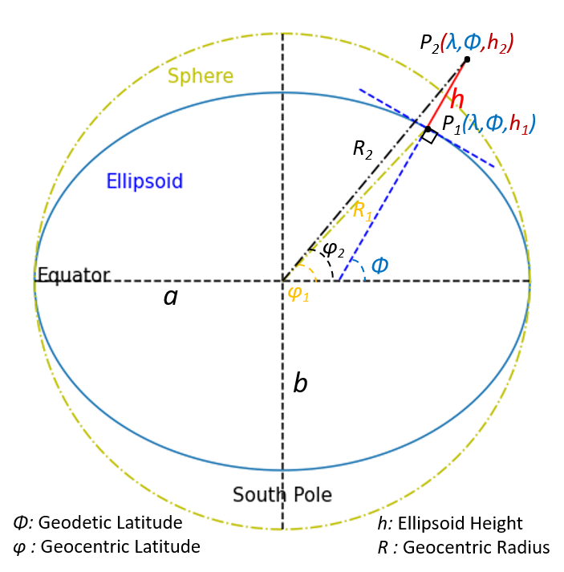
image credit: (The Boule Developers Copyright 2019-2021)
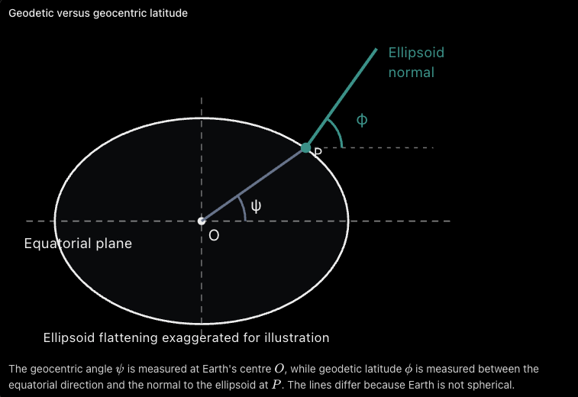
- Geocentric latitude (psi)
  - Geocentric latitude is the angle between the equatorial plane and the line connecting the Earth’s center to the observer
- Geodetic Latitude (phi)
  - Angle between the equatorial plane and the line normal (perpendicular) to the reference ellipsoid at the observer’s position
- Note that for most locations on Earth, psi =/= phi
  - At the poles they coincide
- [insert *interactive model here of {geodetic vs geocentric}]
- Geographic latitude supplied through our GPS and ordinary location lookup is generally geodetic latitude
  - The SPA method provided by (reda and Andreas) calculates relative to the Earth’s center.
    - Thus the SPA implementation in this paper will need to account for the observer’s actual position on the ellipsoid (see topocentric correction)

Observer Elevation
- Latitude and Longitude only identify horizontal geographic position. We need the observer’s position in three-dimensional space
- Let z_ell = observer’s hight above the reference ellipsoid
- The complete geodetic position becomes P = (phi, lambda, z_ell)
- Geodetic height is measured along the ellipsoid normal
- Different from height above mean sea level*
- Elevation affects the observer’s position relative to the Earth’s center (ie. Affects the topocentric correction)
- An elevated observer may see a more distant, lower apparent horizon than an observer at sea level
  - Ex. The top of the Burj Khalifa has a later sunset than the ground floor
- This may be a separate consideration for Sunrise and Sunset. For the purposes of this application, we will treat observer elecation as an optional parameter and subject to a scholarly assumption (see section 3 Islamic Orientation subsection …)

The local reference frame: Zenith and Horizon
- Now that we have a position P on the Earth, what exactly does it mean for the Sun to be above or below the horizon?

Islamic Orientation

Fajr - Begins at (Fajr al-Sadiq), which is marked by a white or faint horizontal band of light spreading across the eastern horizon. Ends strictly at sunrise (Shuruq)
Dhuhr - It begins shortly after the sun reaches its highest point in the sky (zenith/meridian) and starts to decline, casting a slight shadow to the east. Ends when the shadow of an object grows to be equal in length to the object itself (or doubles in length depending on the legal school or Madhab). views (hanafi => double length, Shafi'i => single length) I want to support both
Asr - From the End of Dhuhr until just before Sunset (we will leave 5 minutes between the end of Asr and the beginning of Maghrib)
Maghrib - Just after sunset until the red twilight (shafaq) or afterglow fades from the sky
Isha - When the red twilight (shafaq) or afterglow fades from the sky. Extends until the beginning of Fajr time

